# User manuals

1. User registration：

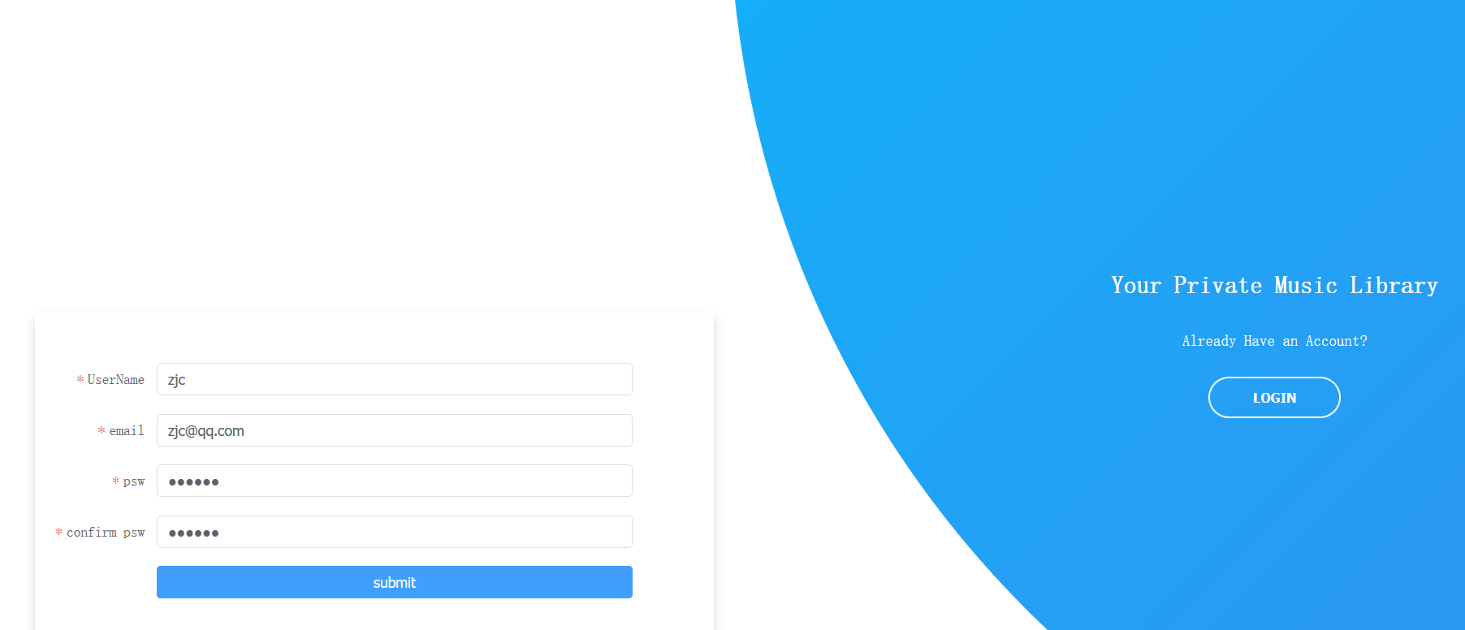

Login using username, email password, checked by corresponding form checks, including email format and password length.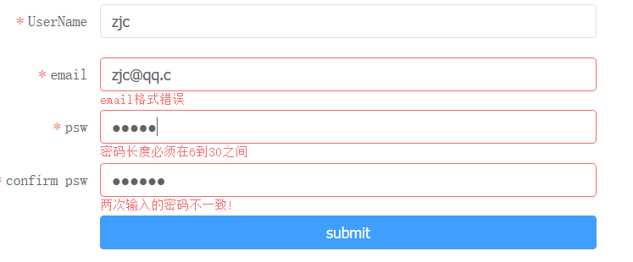

After successful registration you can see the corresponding user information on the administrator screen at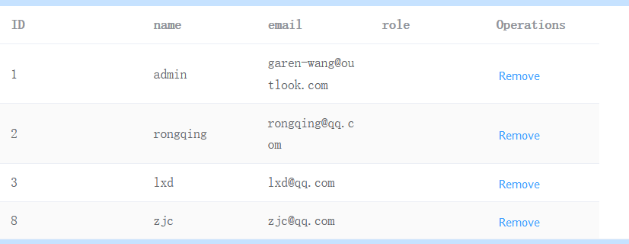

1. User login：

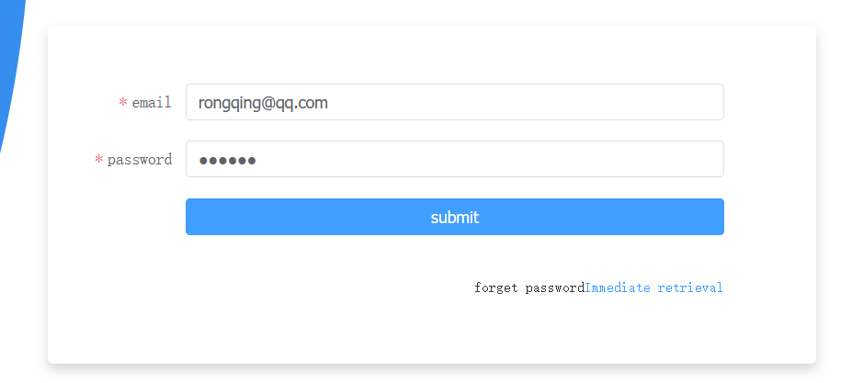

Login via email and password, again with the appropriate form checks..

1. User Page

3.1 Login successfully to the user interface：

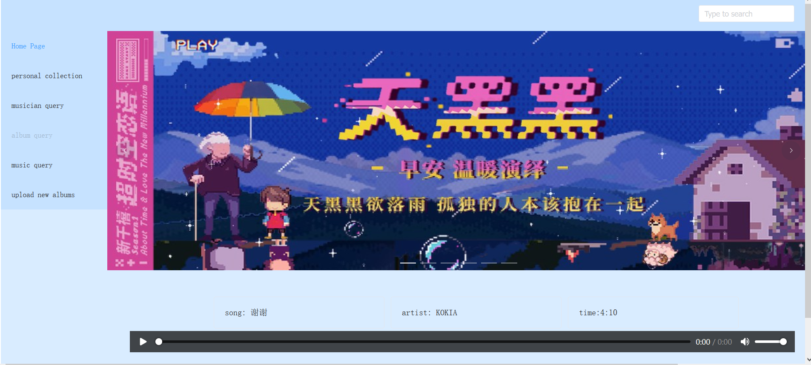

The main user page consists of a header, a menu bar on the left, a looped album information section and an audio section. When the looped album information is clicked, the corresponding music will be played and information about the song will be displayed above the playbar:.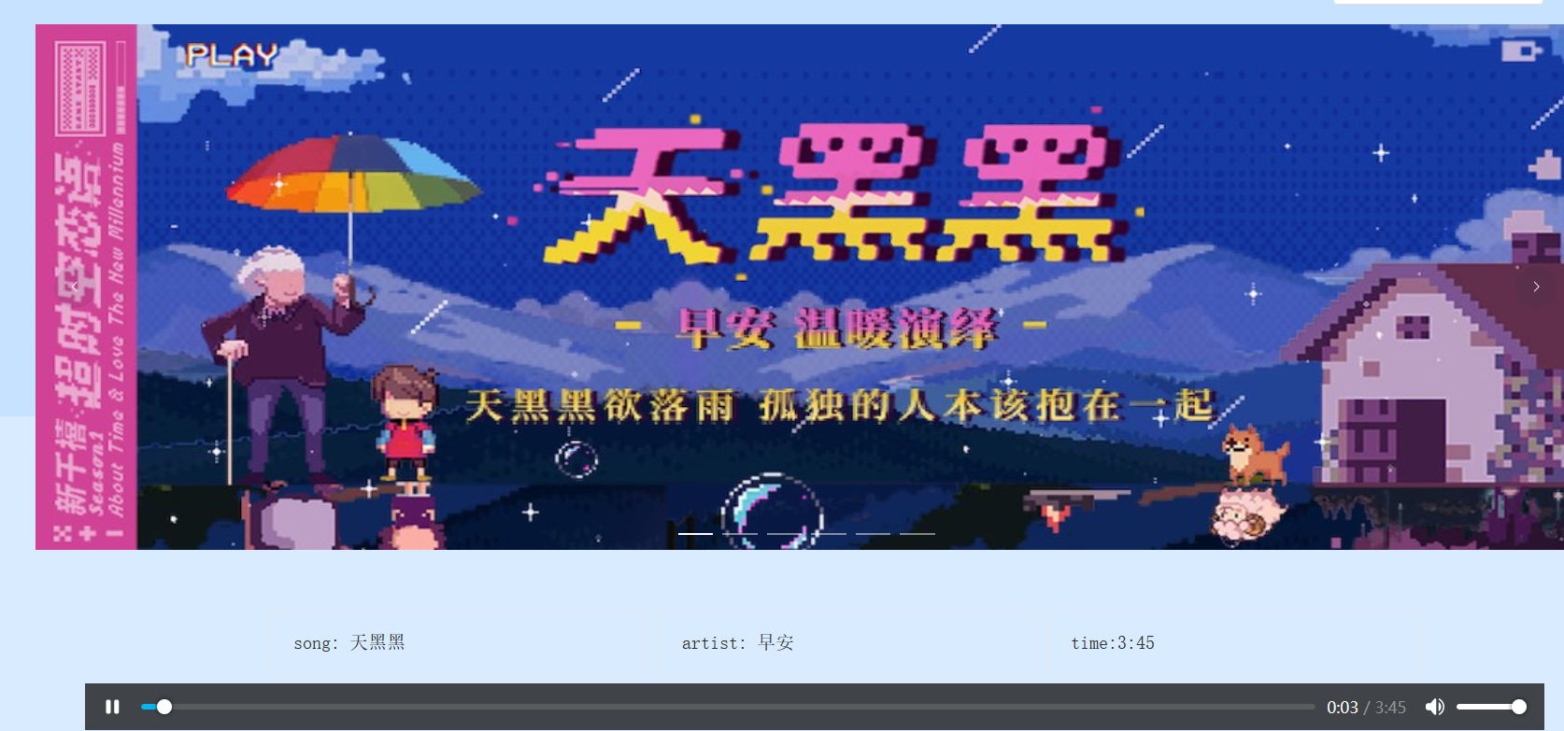

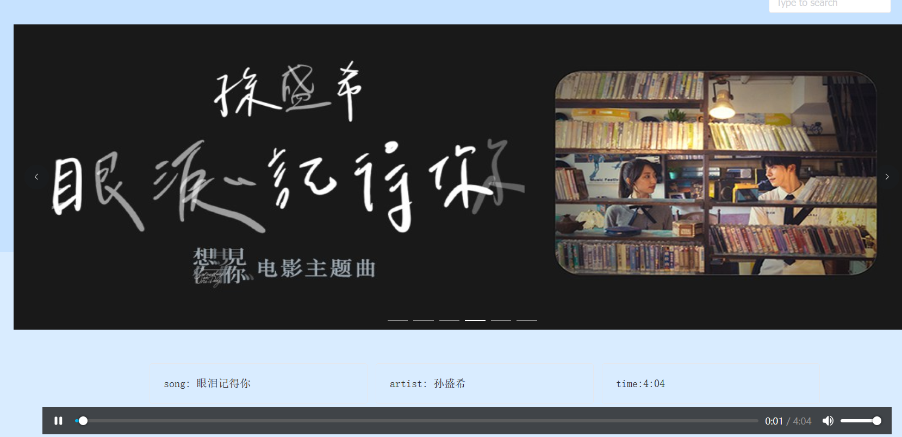

3.2 Collection of albums：

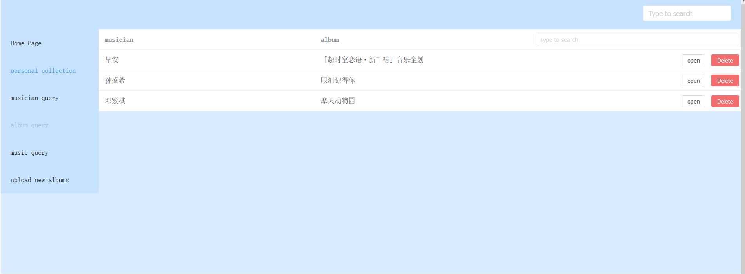

Two buttons are provided, clicking on the open button will open the corresponding album:

Open album “音乐企划”:

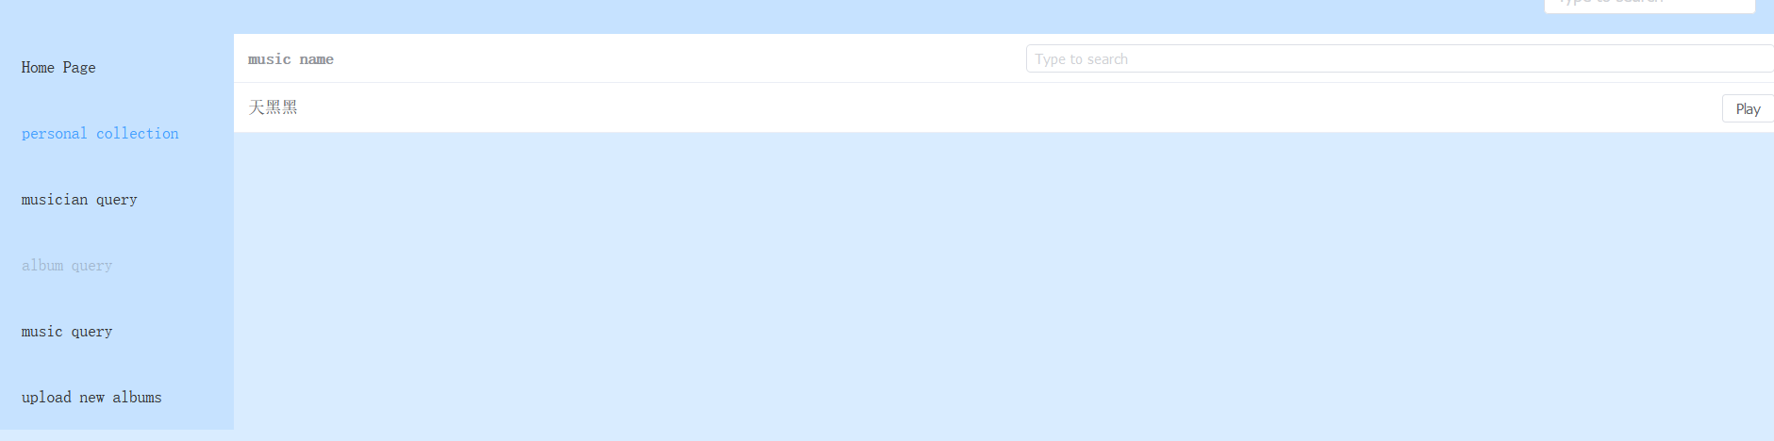

Click on a single track from the album to play.

Click on the play button behind “天黑黑” to jump to the main page to start playing, while recording the last playing time of the song and the corresponding album:.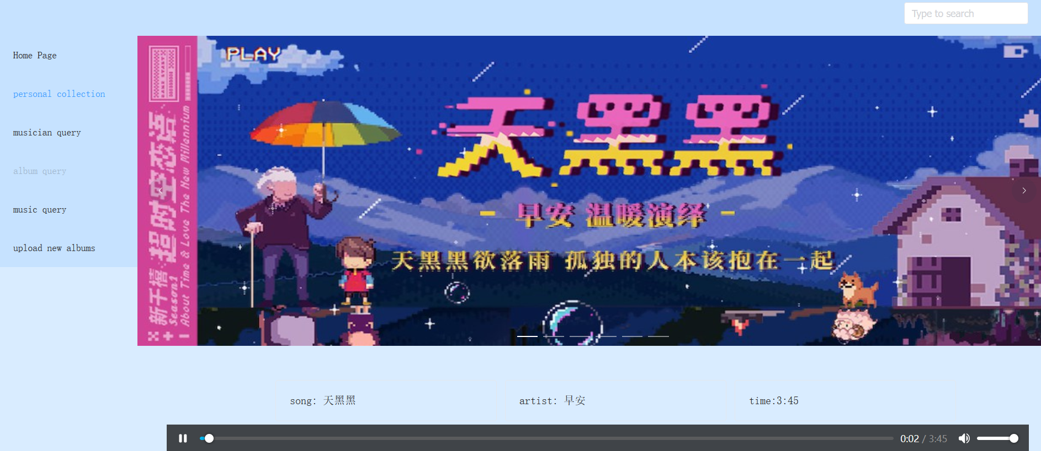

Click on the delete button：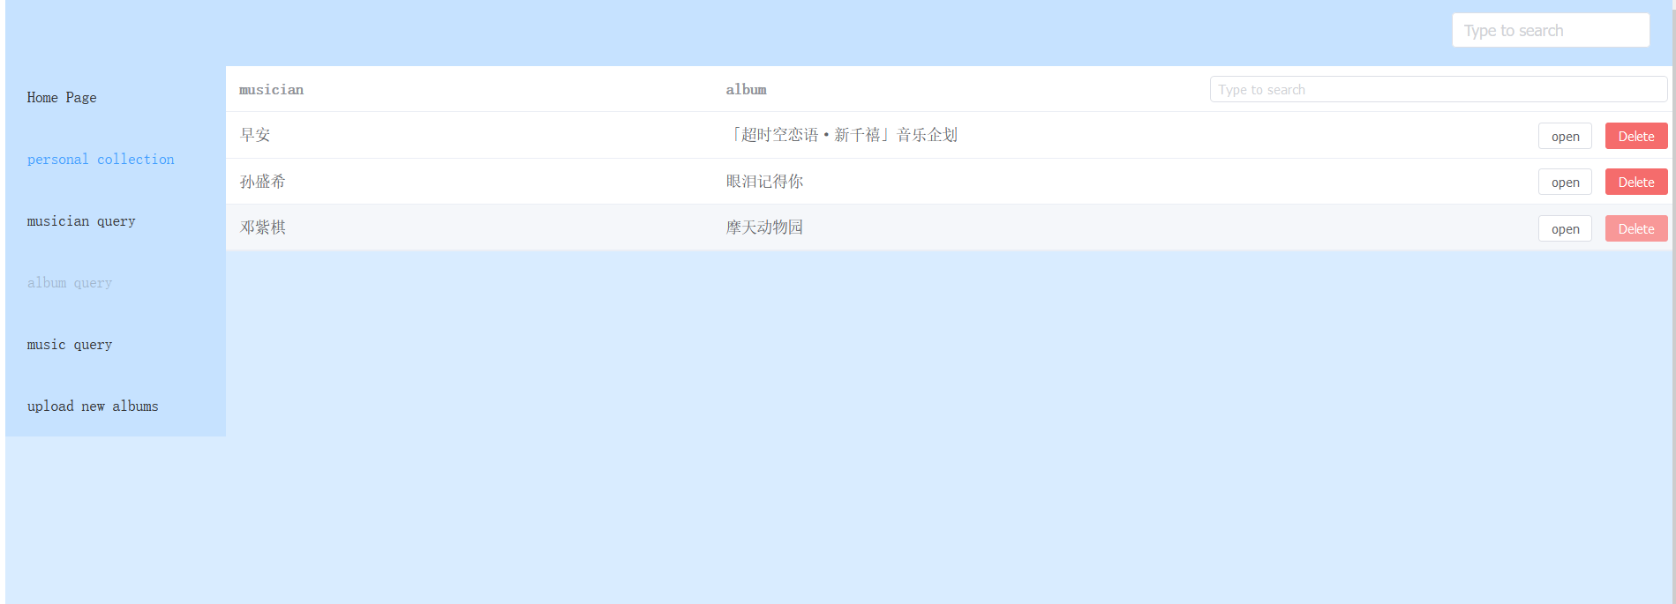

Remove the corresponding favourites from the favourites list (only two albums remain after deletion)：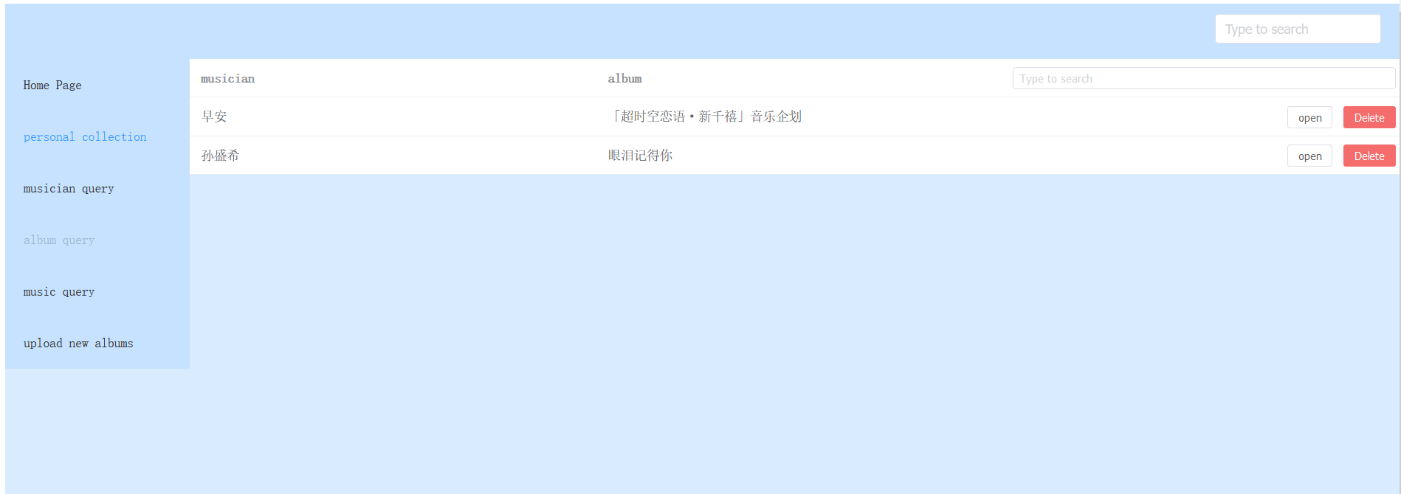

3.3 musician query, displays the corresponding musician and his corresponding album, when an artist has multiple albums it will display multiple albums (e.g. G.E.M):

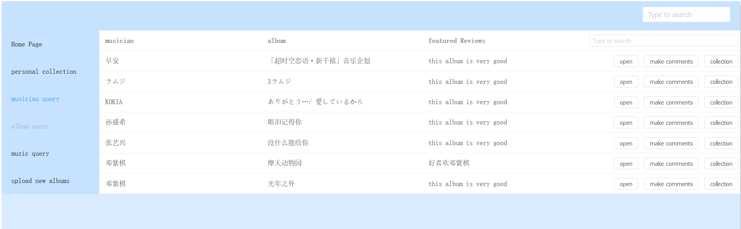

In-page queries are provided (in fact, every page has them, so I won't go into them all, here they are by musician name):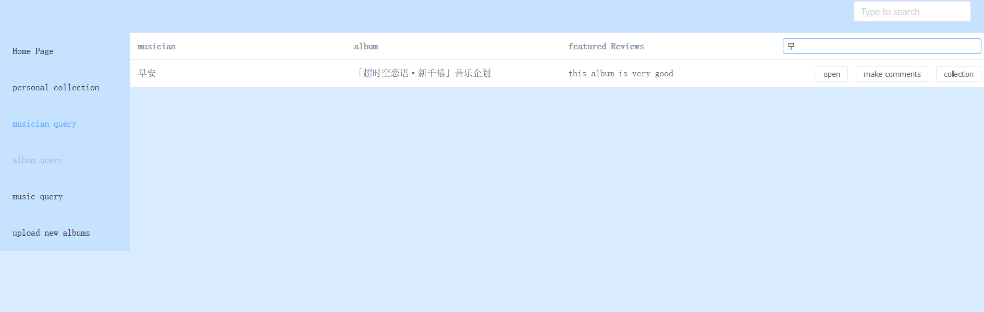

Provides open function to open the corresponding album to view the corresponding single:

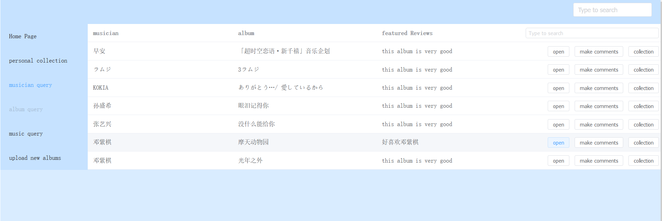

e.g. : Open G.E.M ‘s “摩天动物园” to see two singles available for play:.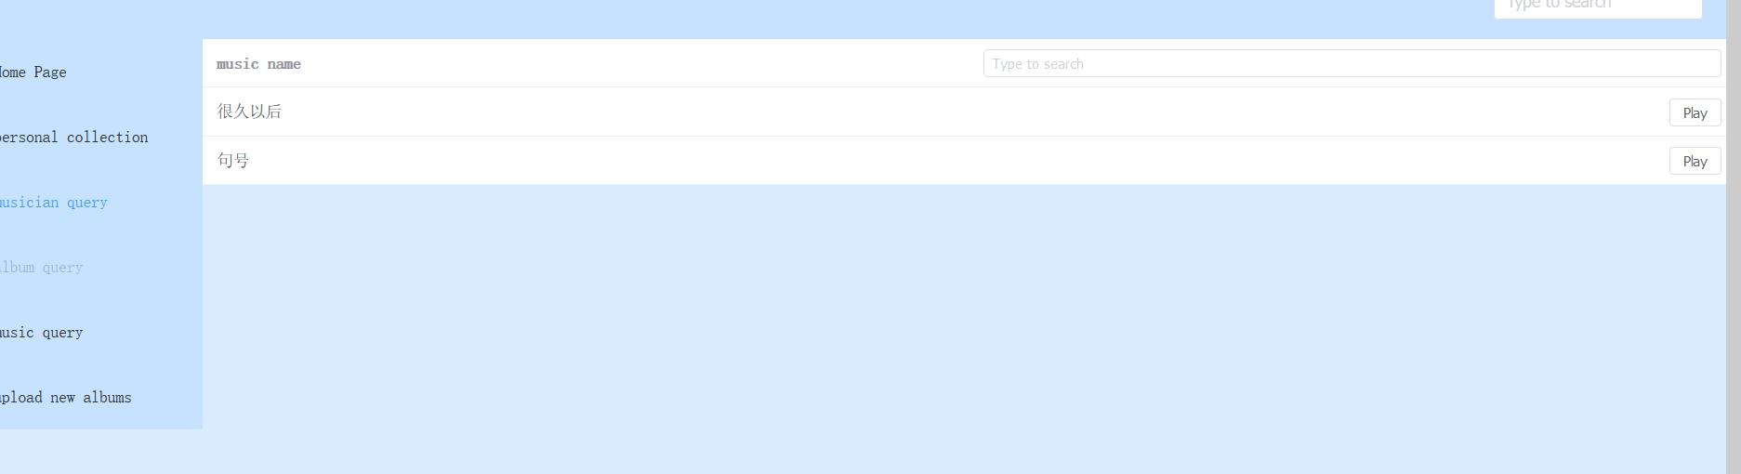

Album review function is provided:

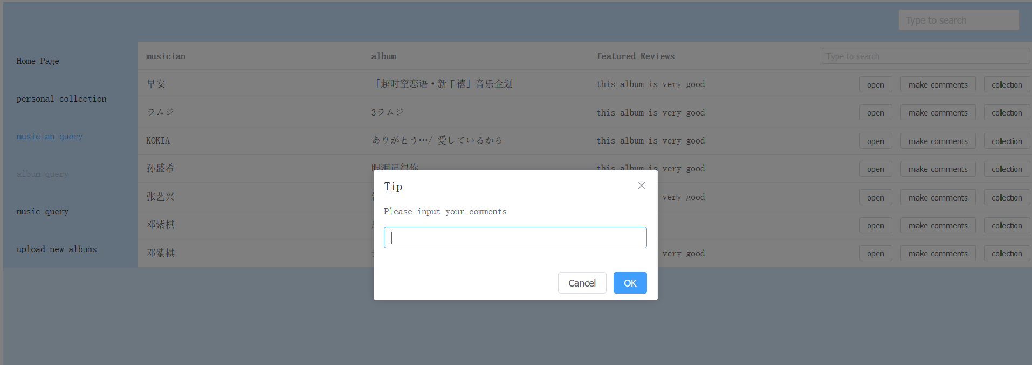

After entering the corresponding comments and refreshing, the latest comments will be displayed by default and all comments will be visible on the admin side: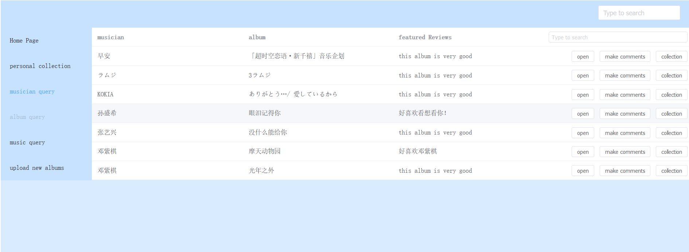

Collection function, click on the Collection button to make a collection of the corresponding album.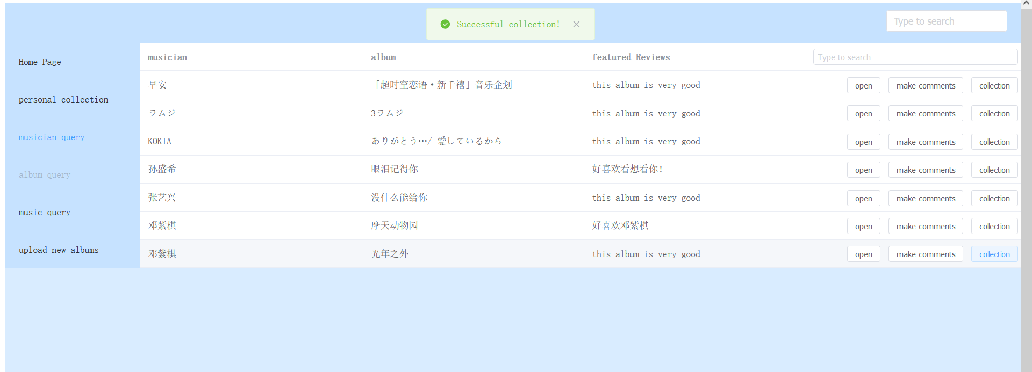

Collected albums can be found in the individual collections section: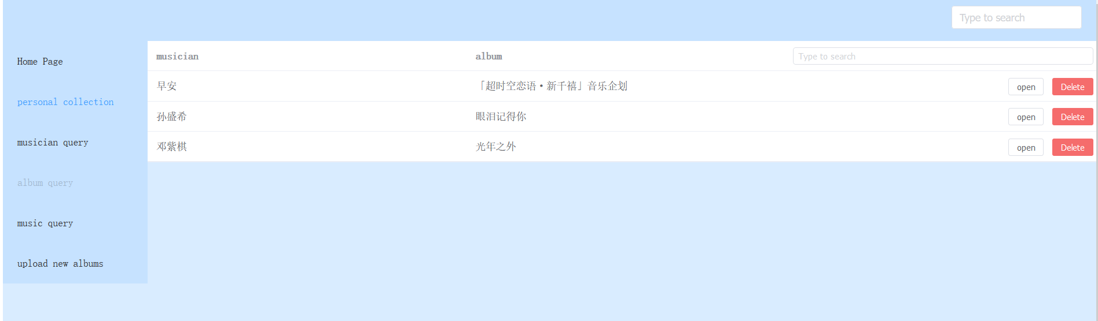

* 1. Single song search：

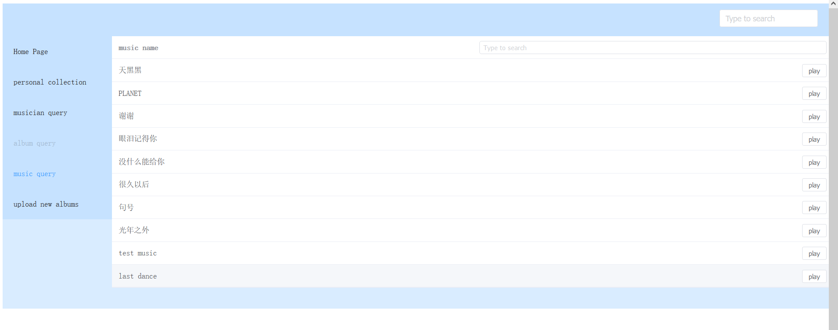 Displays all single songs, can search by single name, provides play function.

* 1. Uploading a new album：

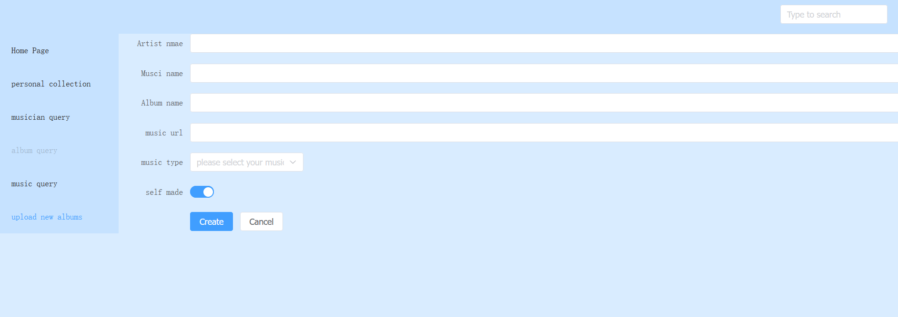

Six inputs are provided and the album can be uploaded after filling the inputs: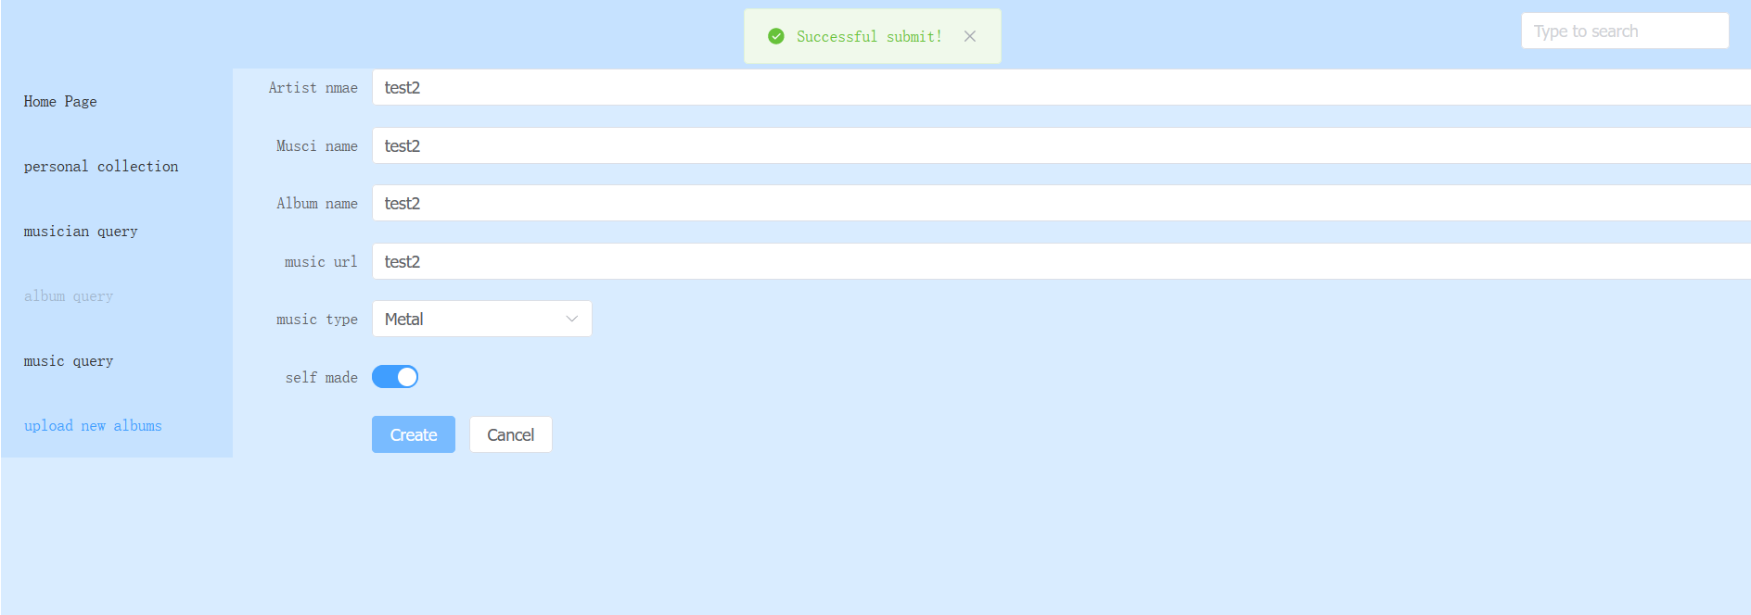

Albums created by users will not be published directly, but will be sent to the admin port for review and approval, after which the corresponding album will be published.

1. Administrator interface:

4.1 The system sets the appropriate administrator account, and the administrator logs in and automatically jumps to the administrator interface:

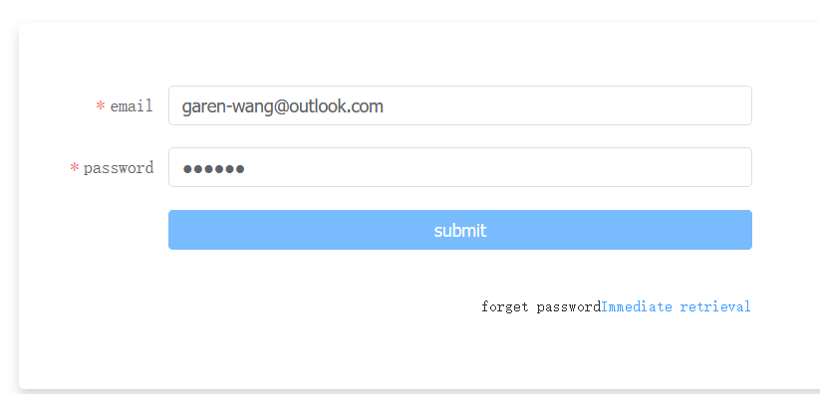

The initial screen for the administrator is the user information, where you can see the new users we created earlier 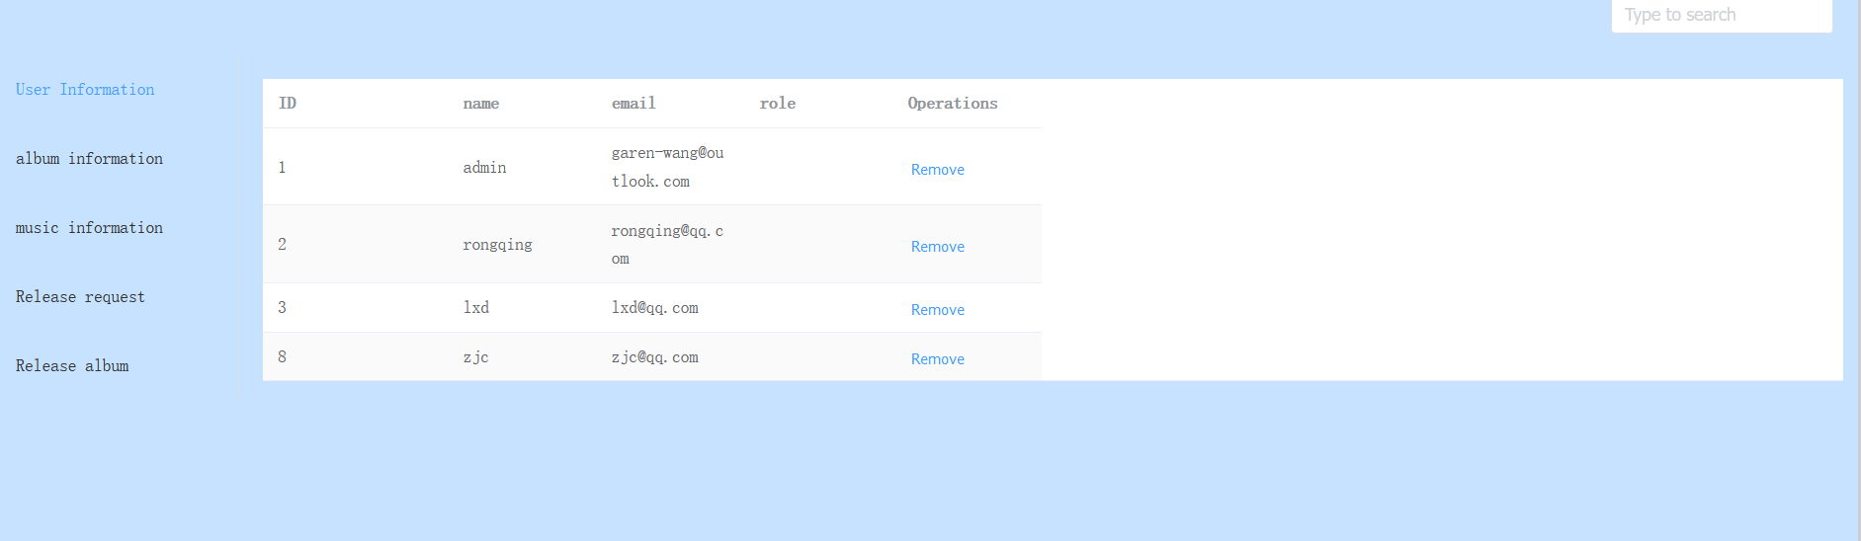

The deletion method is provided and the user can be deleted by clicking on delete.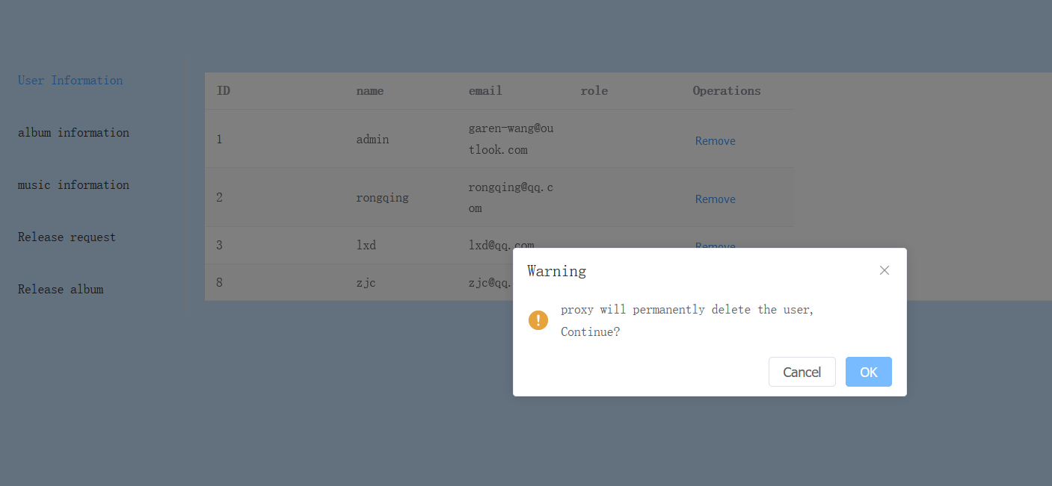

Clicking on the confirmation button will delete the corresponding user. The subsequent menus all provide a deletion function and are not described in detail: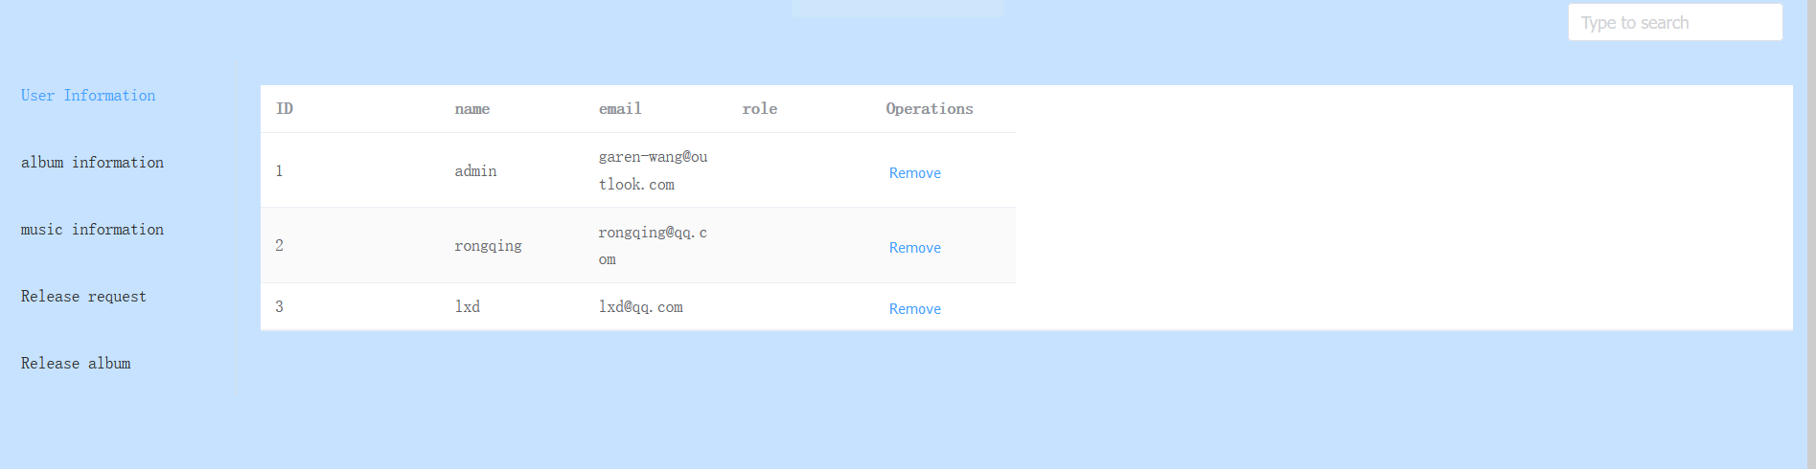

4.2 album information：

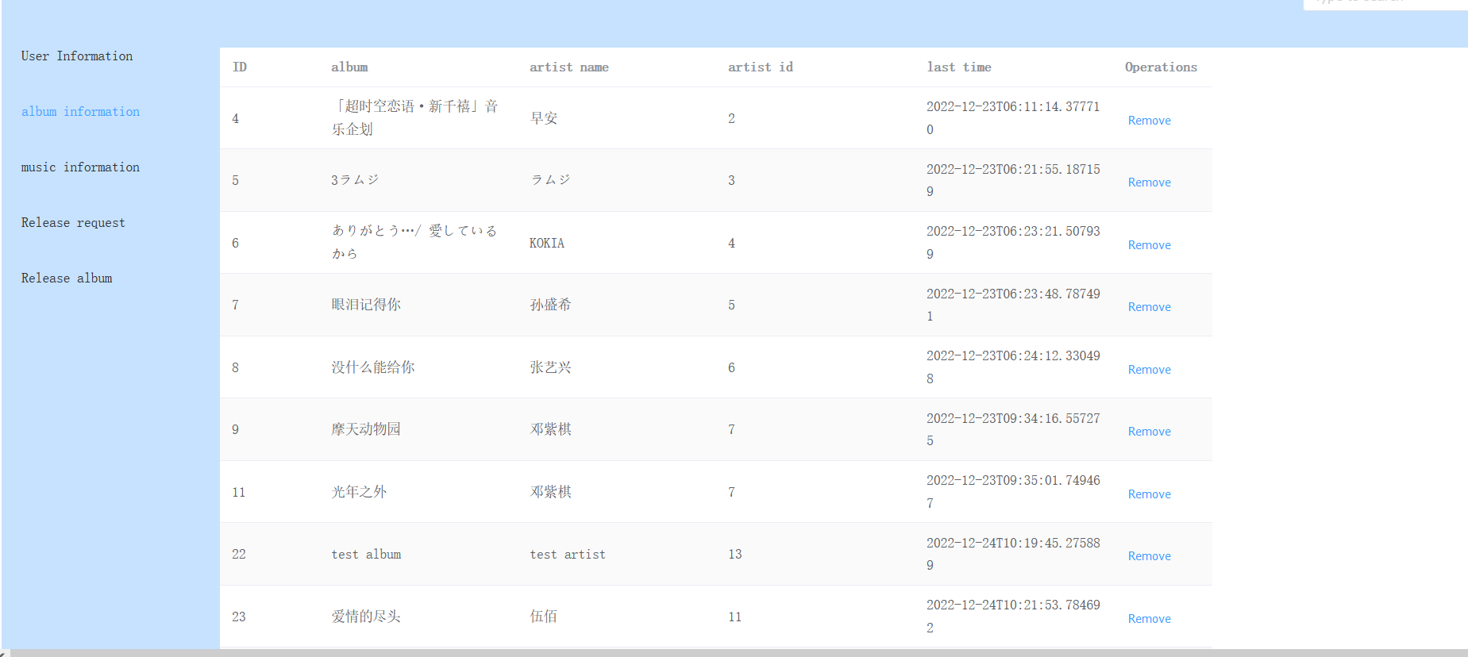

The corresponding albumID, artist name, artist id, last time and delete operations are provided

4.3 music information:

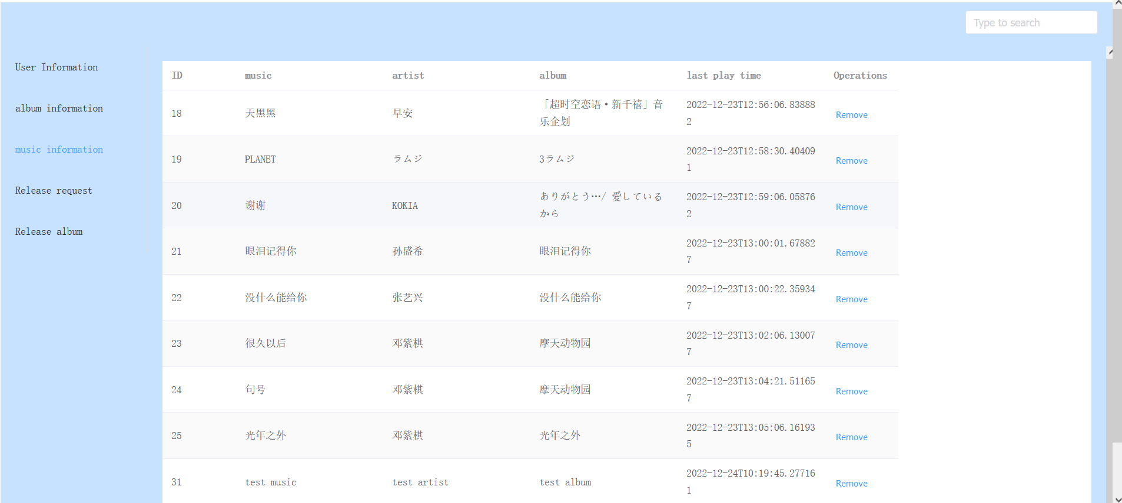

Provides the corresponding music id, music name, artist, album, last play time and delete operation.

* 1. Release request:

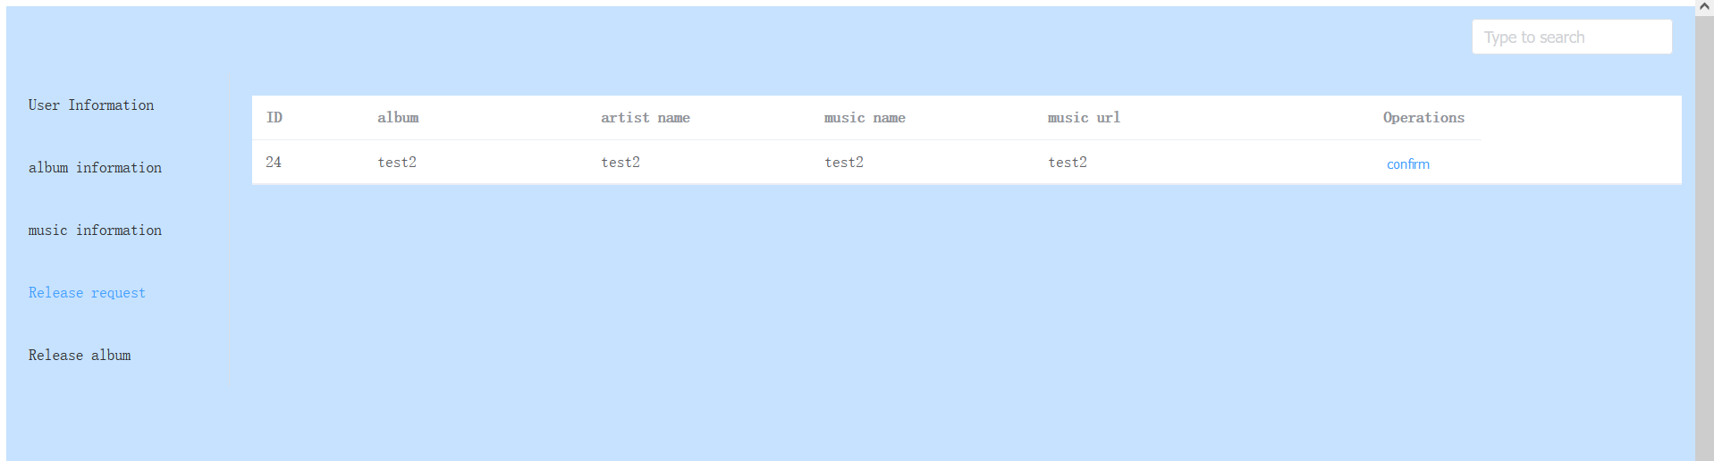

You can see that the album request we just sent on the user side provides a cofirm button to confirm the user's request:

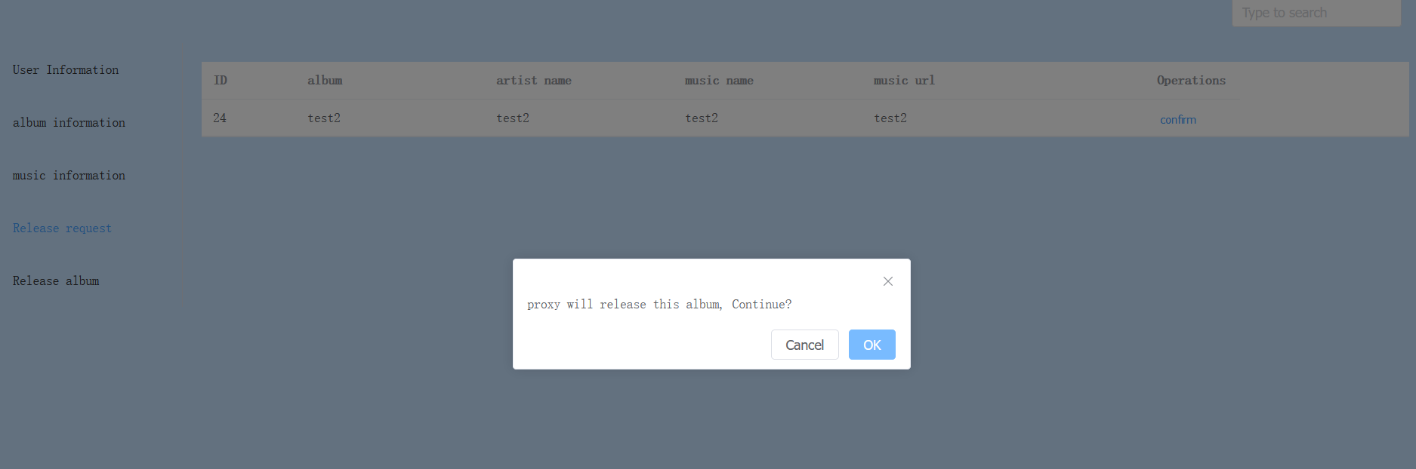

As you can see, the new album has been released to the album library at: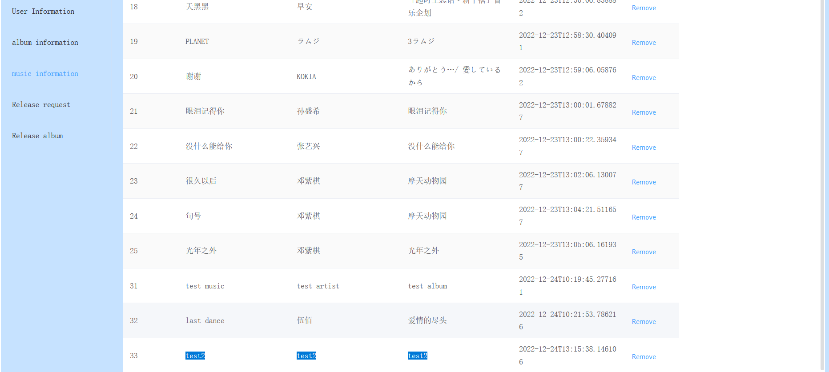

* 1. Release album:

Administrators can also publish albums:

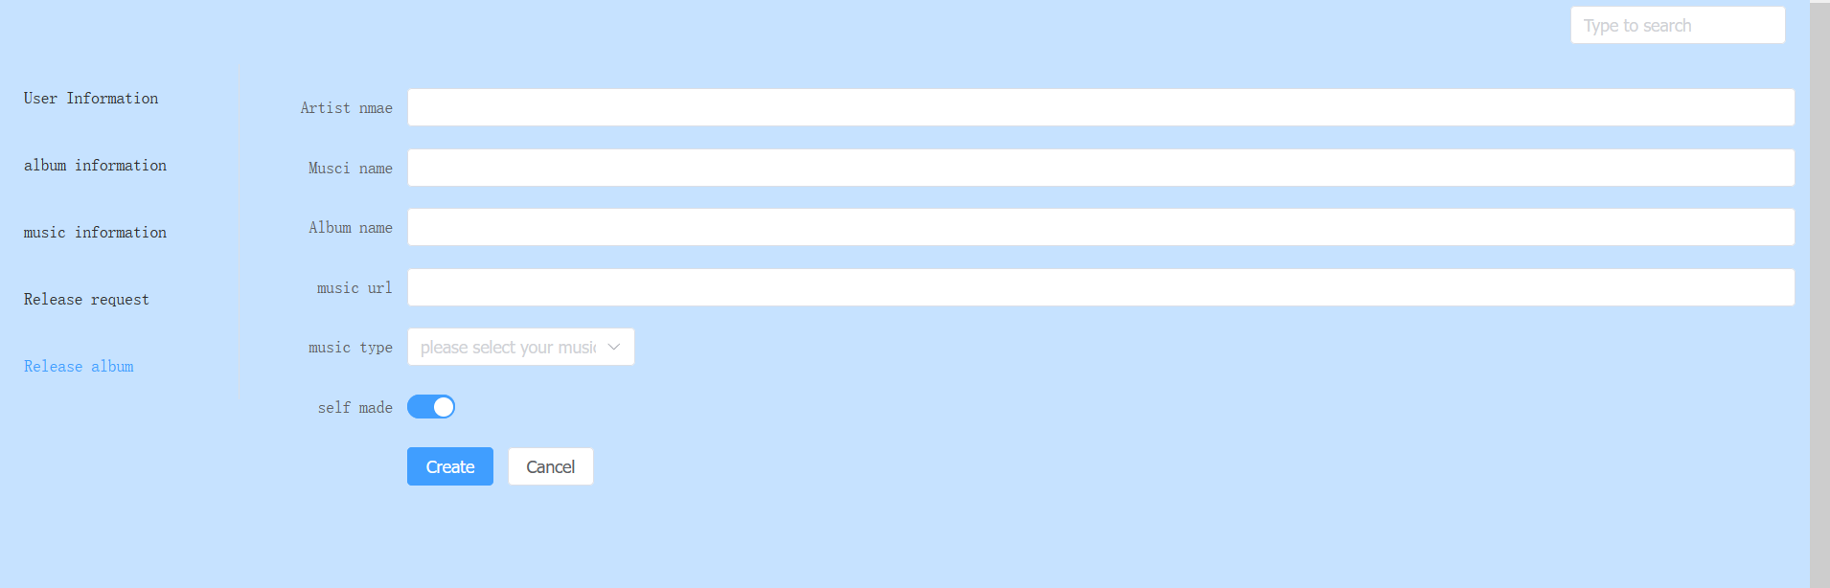

The difference is that albums posted by the administrator do not need to be reviewed:

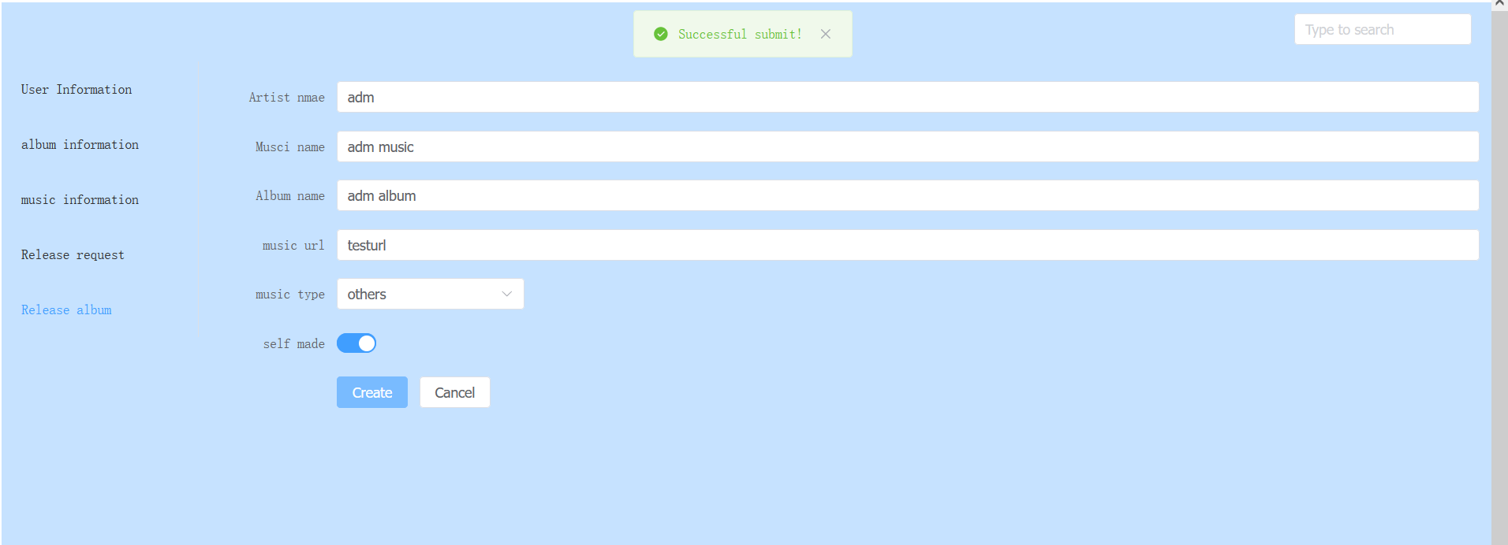

You can see that the albums posted by the administrator are directly passed and displayed in the album library:

